Name _____________________________________________
(Each individual student will complete his or her own lab report)
Bottle Rocket Lab: After launch Questions
Group Members: ________________________________________
________________________________________
________________________________________
- Describe, in detail, how your group’s rocket performed. Was it able to lift off the ground? How high did it go (guess in metres)?

- Did it maintain stability? How did your rocket compare with rockets made by your classmates?

3.) Did your egg survive the launch? If “yes” explain what you did to make sure it survived. If “No”, describe how you would improve the rocket to help the eggs survive if you were to do it again.

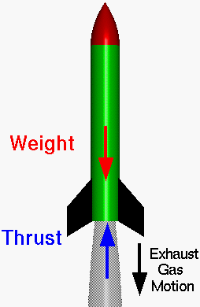
4.) How could you improve your rocket to make it travel higher and farther? What are some specific things you would change/alter?

5.) Bonus: Use your astrolabe to calculate the angle from the ground to how high your rocket fell. Next, you can calculate the height of your rocket by using trigonometry.
Watch the video on Part 1 to see how this is done.
Write the angle from the ground that your rocket flew, using your astrolabe.
[Type a quote from the document or the summary of an interesting point. You can position the text box anywhere in the document. Use the Drawing Tools tab to change the formatting of the pull quote text box.]
? metresm
Angle between ground and height of rocket in Degrees eg. 25º
Distance from rocket launcher in metres eg. 25 metres
_____________

